Roles of Tourism in Dubai

Abstract
Dubai has emerged to be the most influential and popular destination in the tourism industry within two and a half decades. The city has outdone most of the other cities which were involved in the tourism industry for many years ago. However, Dubai is highly favored with its natural structure which attracts tourists. Moreover, Dubai has invested a lot in infrastructure to encourage more visitors in the city including the development of gorgeous beaches as well as best hotels to cater to accommodation, fast technology and communication facilities. The good transportation system is also an added advantage and the shopping festival. Notably, Dubai is highly favored by the political system they have which supports and invest in tourism, for example, sheik Muhammed vision 2020 was based on improving the number of travelers to reach twenty-five million and double the revenues generated with tourist by the year 2020. The award of expo 2020, which the city received motivated them and made them believe in developing the industry. Similarly, Dubai is investing in sustainable development goals; therefore, through tourism, the city will establish renewable power and sustainable water generation strategies to manage tourist needs.

Keywords: Service quality, customer satisfaction, customer loyalty, airline industry.
1.0 Introduction
Dubai is situated on Persian Gulf; to the northeast of United Arab Emirates at the same time being roughly at the sea level provides it a more significant advantage to the tourism industry. Dubai is well-known for its diverse culture and the fundamental milestones that have become a symbol of the resurgence and core of making Emirates appear in the picture of the world. However, the tourism industry is the foundational area of Dubai. Therefore, the UAE's government works at its best to develop the seven emirates in Dubai to help capture the attention of the tourist. Similarly, Dubai has also shown significant development in infrastructure that aids in the tourism industry, such as the tourist facilities, including improving the level of services they offer in transportation and the hotel sector. Moreover, Dubai is also known as the city of many faces as it is the home of the tallest tower worldwide, the Burj Khalifa, and full of adventure opportunities. These activities arise from activities such as the desert safaris through the golden Arabian dunes, reef and wreck diving, skydiving over the beautiful palm as well as wakeboarding. The paper will research the roles tourism has played in Dubai and the growth of tourism and its future together with relevant tourism information to aid in the growth of Dubai.

- Literature review
Zaidan & Kovacs (2017) have researched the impact of tourism on culture and local society. Over many years, tourism has always been claimed to be an enemy of cultural identity and authenticity of people as it dramatically involves modernization. However, the view of tourists has had significant changes and is currently seen as supporting people’s culture. Tourism is referred to as the temporary movement of people from their usual place of habitation to other areas as well as other activities encountered with them to satisfy their needs (Zaidan, 2016). Therefore, when these people move from their place of habitation, they will have adverse effects in areas that they have traveled to hence affecting either positively or negatively the culture of other people and their economy (Du et al., 2016). Tourism has, therefore, increased the practice of the host population using their culture and progressing their values and traditional lifestyles.

Dubai has excellent characteristics that favored the population growth, which acted as a primary driving force fueling the successful Emirates tourism development strategy. The town has utilized a lot of time as well as money in developing modern cities (Sokhanvar et al., 2018). Besides, there has been the rise of Dubai’s political progress, such as having good regional and international communications and having leaders who have visions. Also, the location of Dubai been situated between East Asia, and Europe has also favored it as well as high-quality infrastructure, attractive winter climate and environmental landscape. Dubai again encourages tourist because of the low import duties as well as traders are inspired to do business in the town due to absence of taxes on corporate and personal incomes (Zaidan, 2016). All tourists always require a pleasant environment that can make them feel secure with their properties and also safety for their lives. The safe means of getting things also encourage tourists to go to Dubai as they will get all their needs. According to Sheikh Mohammed, the vision for Dubai is to make twice tourists number by year 2020.

Karmakar (2015) posits that infrastructure tourism has resulted in development of infrastructure in Dubai. For the tourism sector to advance, it relies heavily on the infrastructure of a country such as the right roads, electricity availability, potable water, a proper sewage system and airports. Therefore, through Dubai working tirelessly, they can enhance their infrastructure and thus attracting more tourists. However, although the competition of tourists has dramatically increased in past few years, Dubai has progressed in supply chain of infrastructure from transport to environmental and social infrastructure. According to Elgaali et al. (2019), there exist several activities that should be performed to guarantee sufficient tourist and related infrastructure including; one, building new accommodation capabilities within the country that will favor both classes of people.

Correspondingly, certifying easy accessibility to the destination of travel and also within the destination by use of different forms of transportation. Thirdly is to elevate the existing accommodation capabilities, such as using modern equipment's and also upgrading it with the latest technologies required (Hafeez et al., 2016). Fourthly, it is to enhance the communal infrastructure such as the chairs being used by every person in the destination to be able to bring a different view to the tourist of the place they visit. Fifth is to focus on destination safety and cleanliness as people always require to have guaranteed security for their life; no one would like to be in a place where their safety can be hindered and hence risking their life (Kavunkil, 2017). Sixth is to develop essential structures; for example, not all people are always in need of the latest infrastructure; however, the government of Dubai should perform research and realize which type of infrastructure is needed most and develop them. Finally, is to improve on the quality they offer, most of the tourists are always on the move for better services in places where they go; also better services offered makes the tourist need to be back in the region again.

Anuradha (2017) argues that tourism development improves the country as well as eager to learn and provide high-quality services. Tourists come from different areas and hence have diverse cultural backgrounds that require the hospitality members to learn and acknowledge the diversity of people. The hospitality department is highly developed to meet international standards through good designs in accommodation and catering services for tourists. Dubai also benefits engineers trying as much as possible to focus on designs that are more appealing in attracting tourists in return, making the city even more beautiful. Besides, Dubai has a unique landscape as well as culture and history, which increases the attractiveness of the tourist (Salama, 2015). Other features that improve because of tourism are the communication and telecommunication industry, as people will need to communicate efficiently and effectively. Similarly, the recreation and leisure facilities also increase as people from the diverse areas come to Dubai with their types of sports and leisure activities such as art fairs and introduce them to the citizens of the country; as a result, people adopt them. Lastly is the improvement in education among individuals as people will always need to learn so that they can be able to understand one other.

- Methodology
The research has adopted an ethnographic approach, which is based on the author's experiences in the destinations where visited as well as the use of second-hand data. The research design adopted is descriptive studies, and it includes determining how the world exists, and the roles tourism plays in Dubai. Barbour et al. (2016) argues that the use of descriptive studies is used to answer the question “why” and “how” as well as the questions “what." According to the research, the items to be explored are based on what are the roles of tourism in Dubai. Therefore, the study is descriptive and involves the quantitative analysis of data. Secondary data was used in the research to analyze the roles of the tourism industry in Dubai. Johnston (2017) describes secondary data as information that was collected for other purposes other than the current goal of the research, however, the data used in the current study should, therefore, be of utility and relevance. The researcher collected tourism data for the year 2019 from different online sources.

According to Zaidan (2016), his highness Sheik Mohammed bin Rashid Al Maktoum adopted Dubai's vision of 2020 to create the tourism industry. The goals set were ambitious and comprised of increasing the number of tourists to two hundred million tourists by the start of the coming decade, and also increase the amount of income into three times than the current revenue generated from tourism. The growth of the tourism sector should require the total submission of both the public and the private sector to be able to advance on both the accommodation and facilities needed. The data collected was required to see how information has been trending for the past years and also be able to predict the future and make improvements for better tourism sector in Dubai. Tourism has brought significant changes in Dubai, and the data collected includes the international overnight visitors to Dubai from 2019, information which was obtained from the tourism statistics database in Dubai statistics center, the rank of Dubai in tourism sector with other international cities and also Dubai hotel data.

- Analysis
Forty years ago, Dubai was recognized as dependent on pearl fishing and trade and limited oil reserves. However, in the year 2018, Dubai was viewed as a revolutionary city-state that is quickly intensifying its worldwide outreach and taking a range of significant development projects and attainments. The administration has attained enough confidence in the tourism sector and marketing planning since they received an award of expo 2020 to be able to double the benefits associated with tourist as well as increasing tourist into twenty-five million by 2020 (Singh, 2015). According to the report produced by Dubai tourism, in the year 2018 Dubai had acquired a total of 16.66 million international tourists, and the city had 717 total number of hotels and hotel apartment buildings as well as 118, 039 rooms that were available for accommodation and 493 AED rates for rooms per day. Besides, by the end of June 2019, Dubai had acquired approximately 8.36 million international visitors (Benton, 2019).

Table 4.1: Top tourist destination in Dubai; Dubai tourism statistics 2019
Trip Advisor | Lonely planet
Burj Khalifa | Burj Al Arab
Dubai Mall | Dubai Museum
The Dubai Fountain | IMG Worlds of Adventure
Dubai Miracle Garden | Burj Khalifa
Global Village | Sheikh Mohammed Center For Cultural Understanding
Atlantis Aquaventure Waterpark | Al Fahidi Historical District
Burj Ak Arabi | Madinat Jumeirah
Ski Dubai | Gold Souq

The table indicates the top destinations visited by tourists using the two travel companies, the TripAdvisor and the Lonely planet. As stated above in the table, the two-travel companies are used to aid the travelers because they have user-generated content, online reservations for transportation, travel experience, price comparison tools, lodgings and restaurants.

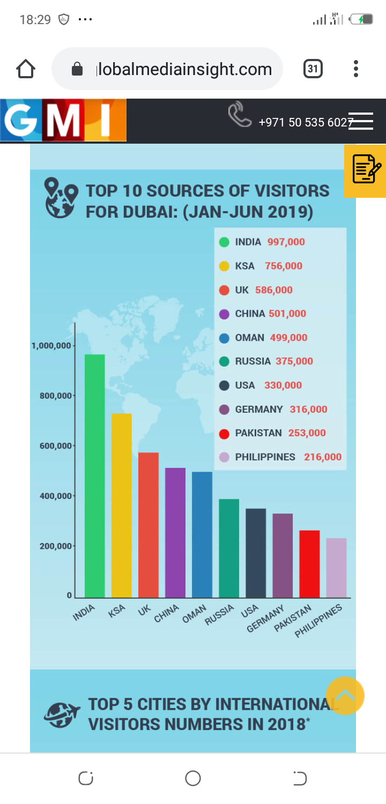
Figure 4.1: The leading 10 countries to visit Dubai; Dubai tourism statistics 2019

According to the graph, the UAE administration aims at new policies to improve the number of tourists by the year 2020 are highly appealing, and the progress indicates that at the end of the year they will achieve it. Leading visitors who visited Dubai from January to June 2019, India was the leading in visiting Dubai with visitors ranging to 997,000 individuals, while the second-largest country to visit Dubai is Saudi Arabia with 756,000 visitors which is followed by the United Kingdom with 586,000 views and then China with 501,000 visitors (AGGENCE-FRANCE-PRESSE, 2020). The next countries are Oman, Russia, the United States of America, Germany, Pakistan and the Philippines, which have less than 500,000 visitors but more than 200,000 visitors.
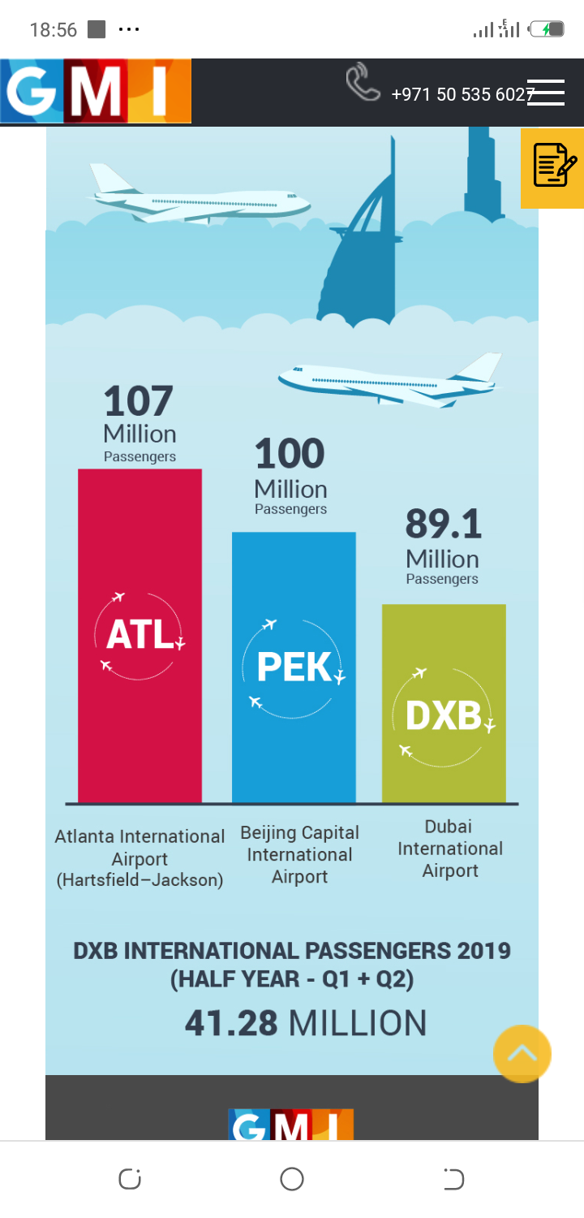
Figure 4.2: World busiest airports; Dubai tourism statistics 2019

During 2018, Dubai International Airport had gained 89.1 million visitors while the others recording high numbers are Hartsfield-Jackson international airport in Atlanta, which was leading with 117 million passengers with the second one being Capital International airport in Beijing with 100 million passengers. Similarly, Dubai international airport has gained more than 41.28 million passengers by June 2019.

- Discussion
During the year 2016, tourism directly contributed 68.5 AED to the country’s gross domestic product (GDP); the amount contributed ranged to around 5.2% of the total GDP. The income generated by tourism is therefore expected to increase by 5.1% each year from 2020 to the year 2027, thus attributing to a total of 5.4% of the total GDP in the projected year (travel guide, 2020). Besides, the total revenue collected from the travel and tourism sector in UAE summed to AED 159.1 billion, which represented 12.1% of overall gross domestic product. Nonetheless, the rise in tourism industry revenue by the year 2027 is expected to be 12.4% of the total gross domestic product.

By the year 2017, the tourism and travel industry had employed 317,500 individuals in the UAE. Still, due to the projected improvement in the tourism sector, the employment rate is also expected to increase by 2.4 percent per year hence employing 410,000 employees. Furthermore, the fiscal policies set by Dubai, as well as the no more than 5 percent of the expenditure are set on debts that create room for achieving up to DH 2 billion. According to Said Abdul Rahman Saleh Al Saleh, who is the director-general, department of finance said that this city can attain the operating increment of DH 1.96 billion because of the implementation of the controlled finance strategies which will subsidize the progress of infrastructure development plans and supports the financial sustainability policies of the Emirates. Dubai has worked extremely hard in developing its infrastructure to be able to create attractiveness to tourists; they need to invest heavily in their roads, hotels, as well as other infrastructure, which will be required by tourists.
Similarly, the tourism and travel sector plays a critical role in economy development. Dubai World Central is anticipated to increase number of visitors in Dubai, and they have started by launching a new airport for passengers’ traffic. According to Fahy (2020), Dubai had 4.7 million visitors in the year 2002 and has amplified to ten million visitors in the year 2019, which is expected to increase to 20 million in 2020. The analyst believes the progress can happen, and through the strategy, the city has used it in opening new airlines, which enables the city to be open for more opportunities as well as more visitors streaming in.
The city has greatly benefited from tourism in different ways especially on the leisure infrastructure. Tourism has resulted in the city developing world-class shopping malls; five-star hotels have been developed enabling Dubai infrastructure to make a step ahead of other cities. Although tourism has aided the city to grow and develop, the city also has features that favor tourism such as the wonderful beaches which act as an attraction to the visitors and waterparks. Similarly, when developing and creating another attraction site in Dubai the trend for increasing visitors will continue.

Correspondingly, the development of Bluewater in Dubai also leads to increased revenue to Dubai and made the place well recognized in the world. The Bluewater was developed to feature the world’s largest Ferris wheel and is referred to as the Dubai eye. Moreover, the tourists’ number increase did not just have a positive effect on Dubai but also other places in Emirates benefited from it. On the other hand, Dubai approved a three-year budget of Dh 196 billion last year with this year's budget being the highest ever at Dh 66.4 billion. The high budget is set to support the Expo 2020 as well as improve the economy of Dubai (visitdubai.com, 2019). In addition, the spending of the country is expected to increase by 17 percent from last year to this year according to the budget. For that reason, the country is working to deliver economic incentives with the aim of enticing investors and work towards improving the competitive position of the country (Soto, 2016).

Dubai has also worked hard in championing for rooms for every visitor, for example during the year 2019 Dubai had more than 16.66 million visitors coming from different areas in the world. Despite, the city having features that are more attractive to the visitors, they also have more advanced and equipped accommodations to be able to handle the increased number of visitors. The emirates have seven hundred and seventeen hotels consisting of several rooms with different prices ranging, which would cater to both the luxury and the lower-class level of visitors. All the hotels have 118,039 rooms, and the average price per room is rated at 493 AED. The international visitors for the first half of the year 2019 were 8.36 million, which is a good number.

On the other hand, Dubai is located at the center, and the location makes it be more advantageous for visitors. The geographic location of the city is conveniently at the central location that is equidistant from both the east and the west, hence, making the city enjoy the hub for travelers from Asia traveling to Europe and North America. Additionally, Dubai has more attractions, such as the tallest skyscraper and the biggest shopping malls. According to Trip Advisor, the most popular tourist site in Dubai is the Burj Khalifa, the tallest building and most visited website. The Trip Advisor also claims that the tallest building is more popular than both the Dubai fountain and the Dubai Mall. However, according to the Lonely Planet travel portal, they have ranked Burj Al Arab as the famous and most visited hotel, similarly, listing both IMG Worlds of Adventure and Dubai Museum at the top of Burj Khalifa.

- Conclusion
Having discussed the roles tourism has played in Dubai and the growth of tourism and its future together with relevant tourism information to aid in the growth of Dubai, it is evident that the administration of Dubai has targeted investing its resources to the tourism industry because of the industries long term sustainable growth capabilities. Nonetheless, tourism is also significant in diversifying the economy of the UAE and taking it apart from energy production. Thus, to ensure sustainability in the country, there will be a need for a balance in the marketplace between the tourism industry and the enterprises focusing on developing renewable electricity as well as water production. Dubai is more advantageous in its natural resources as they have more natural and cultural tourism attraction which results in an increased number of tourists. Notably, the government invested heavily in the expo 2020 project which is later to use the total renewable energy hence saving on cost. The government has set ways of improving the infrastructure, even more, to increase number of visitors.

The rate of tourists visiting Dubai is greatly increasing, and the number indicates that the vision 2020 of getting 20 million visitors and tripling the revenue attained from tourism will happen. The more budget set for this year is used for the success of attaining the vision and therefore the development of more airlines to encourage people to travel as well as the government offering business incentives to support more investors and more people to venture into business. In addition, the government is working on increasing the number of accommodation and ensuring the homes fits the global standard by fitting the rooms with the necessary requirements. Similarly, the administration should not only focus on luxurious rooms only but also on rooms that will favor lower class people who will need to travel in the city.

Tourism has also played significant roles in Dubai by boosting the economy, although the economy has not only benefited Dubai alone but also the whole of the Emirates. People have invested a lot in hotels, and other businesses to ensure that they satisfy traveler’s needs. The government is again required to develop the roads and focus strictly on enhancing the care of travelers, the more people come in the more services are required and the more resources required, therefore, the administration should have arrangements of making everything work well. When a person is treated well during their first visit, most probably they will come again as they are more interested in the services available. Finally, Dubai has acquired the taste of tourism. Consequently, through putting more effort into their strategies and working on sustainable goals they will need to have trained employees who would perform their work in a more proficient means as well as other resources such as water, power and transport means. Besides, the government should also spend on safeguarding and monitoring the performance of factors such as the culture and the natural resources which act as a tourist attraction.

7.0 Limitations and Future Directions

References
AGGENCE-FRANCE-PRESSE. (2020). Dubai announces record tourism arrivals in 2019. Retrieved from https://www.thejakartapost.com/travel/2020/01/22/dubai-announces-record-tourism-arrivals-in-2019-.html
Anuradha, V. (2017). Deciphering the environmental impact of tourism development in Dubai: Developing sustainable directives and a citizenship agenda. In International Tourism Development and the Gulf Cooperation Council States (pp. 204-221). Routledge.
Barbour, V., Burch, D., Godlee, F., Heneghan, C., Lehman, R., Perera, R., ... & Schroter, S. (2016). Characterisation of trials where marketing purposes have been influential in study design: a descriptive study. Trials, 17(1), 31.
Benton, N. (2019). Dubai's' game changer'. Australasian Leisure Management, (133), 30.
Blogger GMI. (2019). Dubai Tourism Statistics 2019. Global Media Insight. Retrieved from https://www.globalmediainsight.com/blog/dubai-tourism-statistics/
Du, D., Lew, A. A., & Ng, P. T. (2016). Tourism and economic growth. Journal of Travel Research, 55(4), 454-464.
Elgaali, E., Ziadat, A. H., & Alzyoud, S. (2019, March). Environmental Effects of New Developments in the Coastal Zones of Dubai. In 2019 Advances in Science and Engineering Technology International Conferences (ASET) (pp. 1-4). IEEE.

Fahy, M. (2020). Dubai tourism numbers up 5.1 per cent in 2019. Retrieved from https://www.thenational.ae/business/travel-and-tourism/dubai-tourism-numbers-up-5-1-per-cent-in-2019-1.967509
Hafeez, K., Foroudi, P., Dinnie, K., Nguyen, B., & Parahoo, S. K. (2016). The role of place branding and image in the development of sectoral clusters: The case of Dubai. Journal of Brand Management, 23(4), 383-402.
Johnston, M. P. (2017). Secondary data analysis: A method of which the time has come. Qualitative and quantitative methods in libraries, 3(3), 619-626.
Karmakar, A. (2015). E-governance and its role in infrastructure services of UAE, case study—Dubai. In E-Governance for Smart Cities (pp. 81-97). Springer, Singapore.
Kavunkil Haneef, S. (2017). A model to explore the impact of tourism Infrastructure on destination image for effective tourism marketing (Doctoral dissertation, University of Salford).
Salama, H. H. (2015). Dubai: An Urbanism Shaped for Global Tourism.
Singh, B. (2015). Smart City-Smart Life: Dubai Expo 2020. Middle East Journal of Business, 55(2473), 1-4.
Sokhanvar, A., Çiftçioğlu, S., & Javid, E. (2018). Another look at tourism-economic development nexus. Tourism management perspectives, 26, 97-106.
Soto, R. (2016). Competitiveness and Sustainability of Tourism. The Economy of Dubai, 58.
visitdubai.com (2019). DUBAI TOURISM 2019: PERFORMANCE REPORT. Retrieved from https://www.visitdubai.com/en/tourism-performance-report
Zaidan, E. A. (2016). Tourism shopping and new urban entertainment: A case study of Dubai. Journal of Vacation Marketing, 22(1), 29-41.
Zaidan, E. (2016). The impact of cultural distance on local residents perception of tourism development: The case of Dubai in UAE. Turizam: međunarodni znanstveno-stručni časopis, 64(1), 109-126.
Zaidan, E., & Kovacs, J. F. (2017). Resident attitudes towards tourists and tourism growth: A case study from the Middle East, Dubai in United Arab Emirates. European Journal of Sustainable Development, 6(1), 291-291.

